E-Library

All existing library system where managing using manual entries or computer entries where admin or librarian has to record all details such as Book Name, student name, issue-date and applying penalty and all completing all this task is time consuming process and to overcome from this issue we are designing E-Library where ADMIN will upload various types of tutorials like Videos, tutorial URL and all types of files like PDF, WORD, PPT etc.

Any student can signup with the application and then login and can search desired book with desired type. No manual management required

To implement this project we have designed following modules

1. Admin Module: admin can login to application using username as ‘admin’ and password as ‘admin’ and then can add new book, video and URL etc. Admin can view all books and can delete book data.
2. Student Module: student can signup and login to application and then can search desired type of tutorial by giving search query.

To run project first copy content from ‘DB.txt’ file and paste in MYSQL and then double click on ‘run.bat’ file to start python DJANGO webserver and get below screen

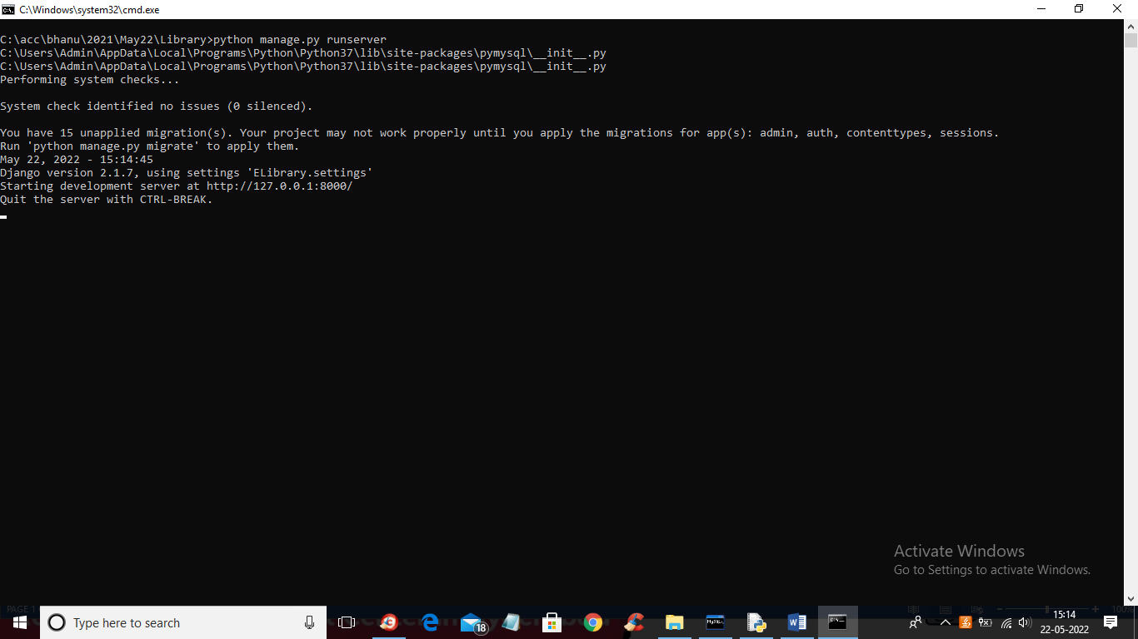

In above screen python DJANGO server started and now open browser and enter URL as http;//127.0.0.1:8000/index.html and press enter key to get below screen

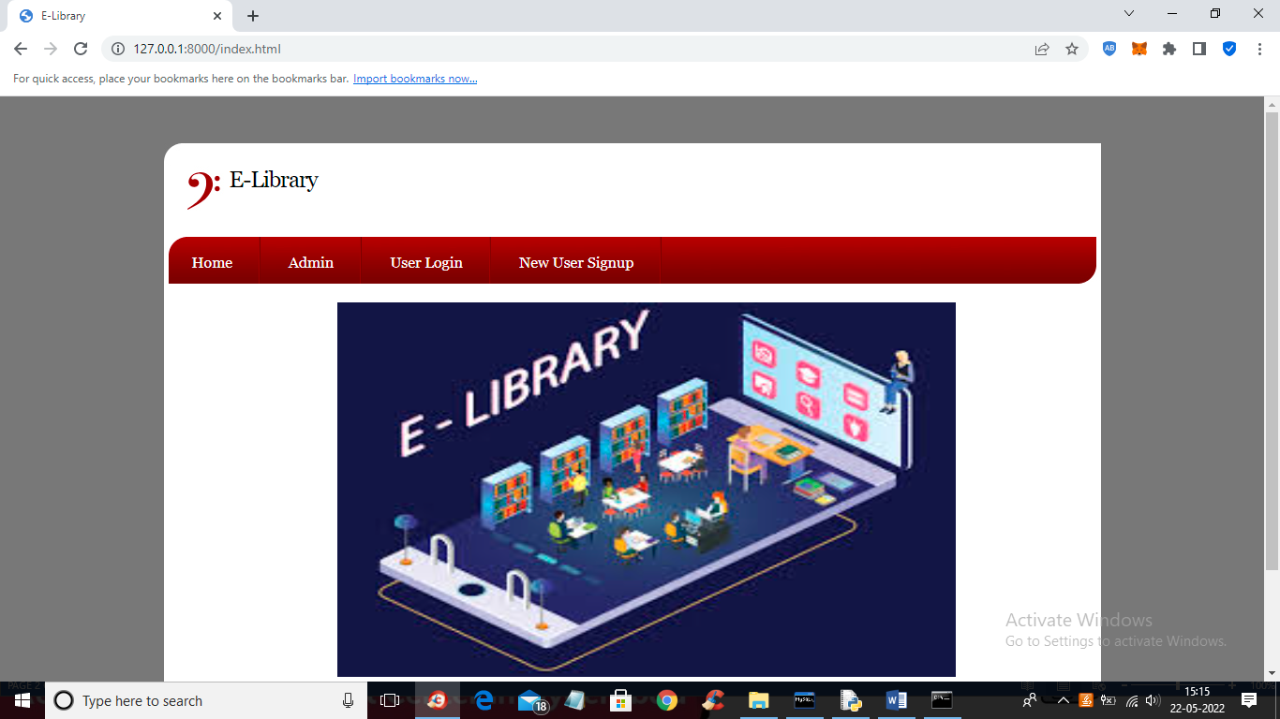

In above screen click on ‘Admin’ link to get below login screen

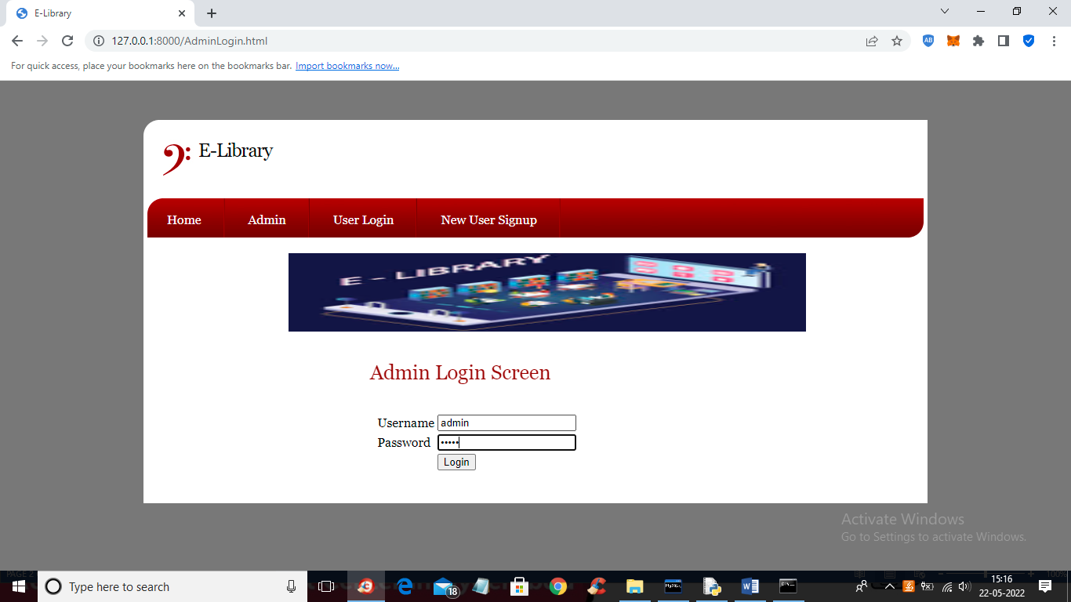

In above screen admin is login and then click on button to get below screen

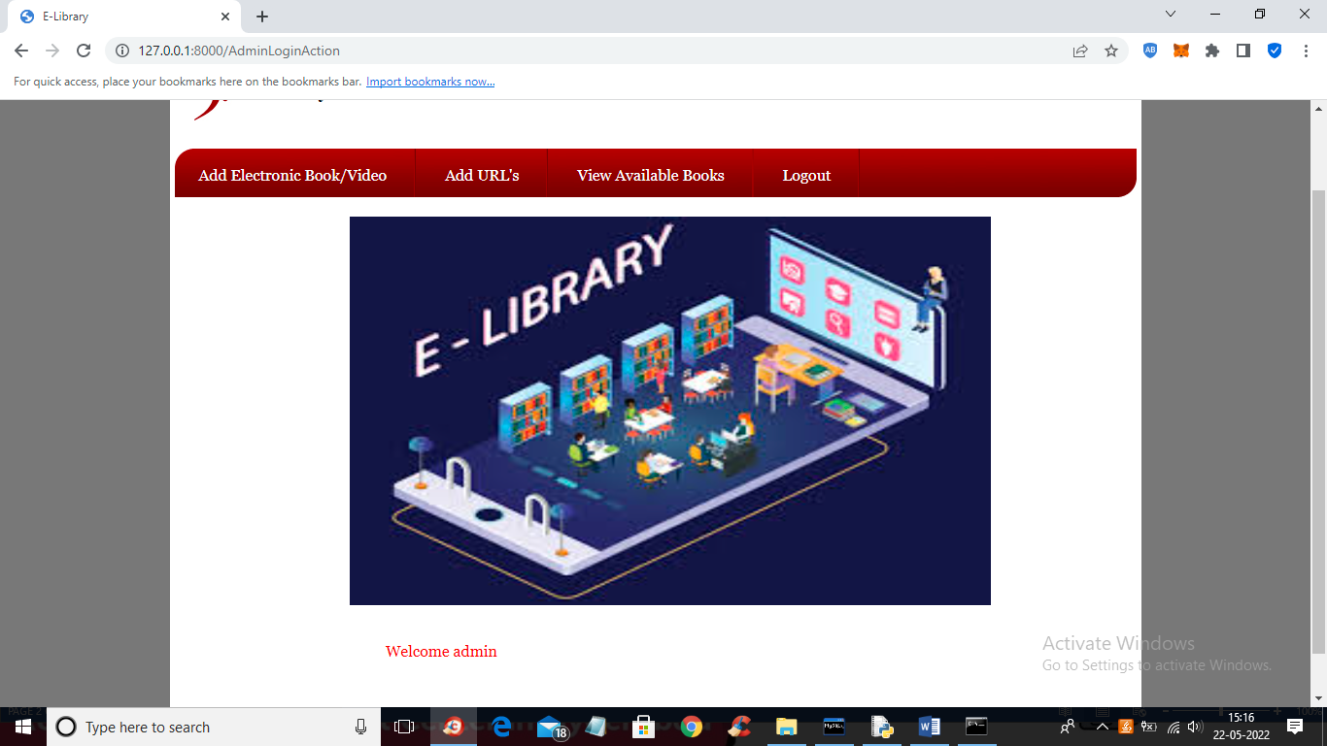

In above screen admin can click on ‘Add Electronics Book/Video’ link to add book or video

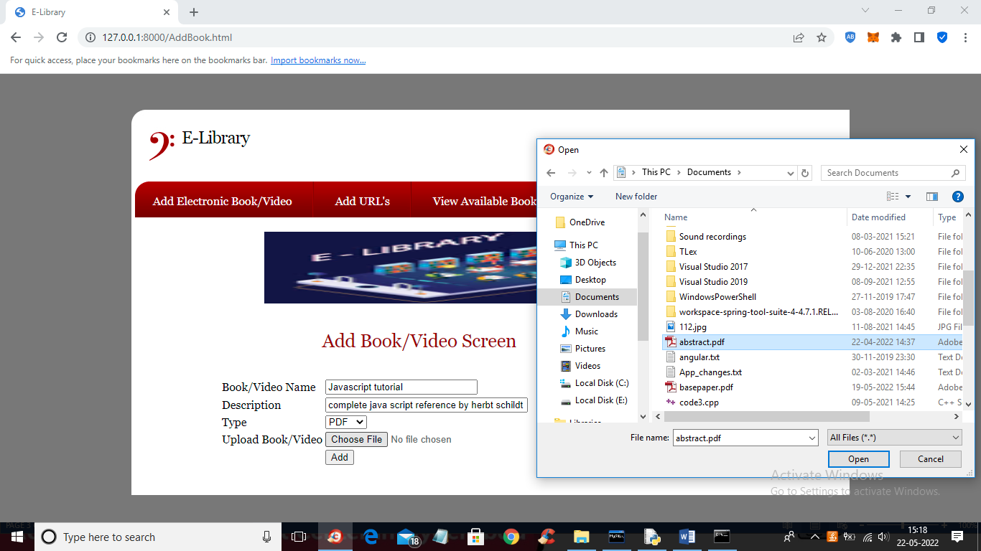

In above screen admin is uploading PDF file and then click on ‘Open’ and ‘Add’ button to add book to database and similarly admin can upload video also

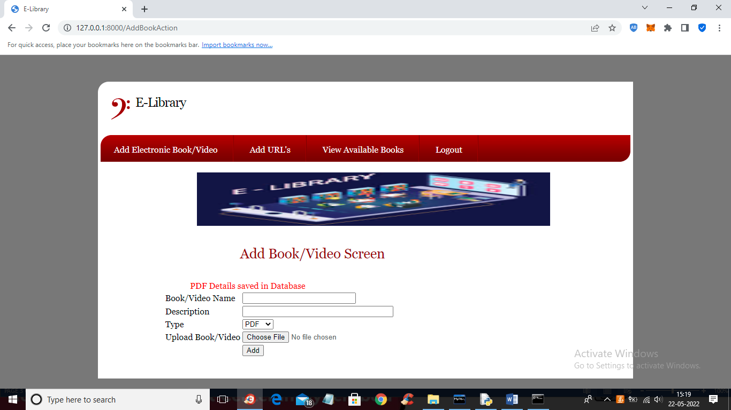

In above screen PDF details added to database and similarly you can add other books also

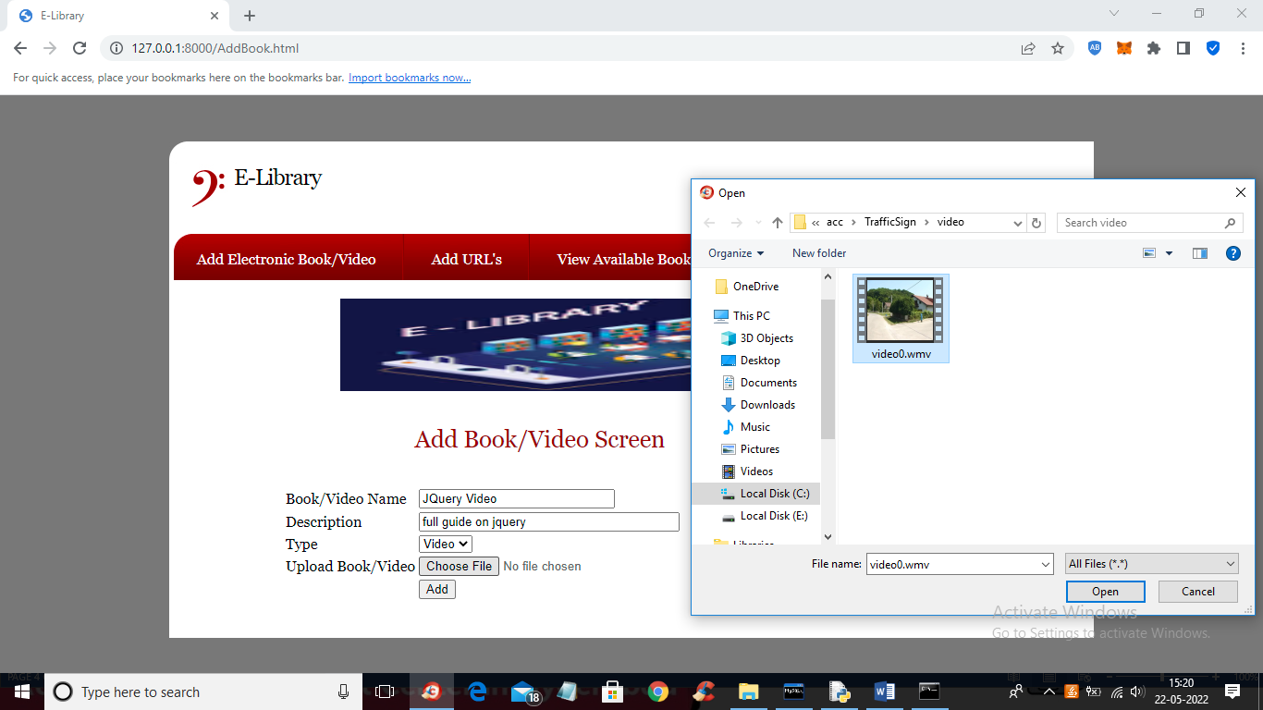

In above screen admin is uploading video tutorial and click button to add details

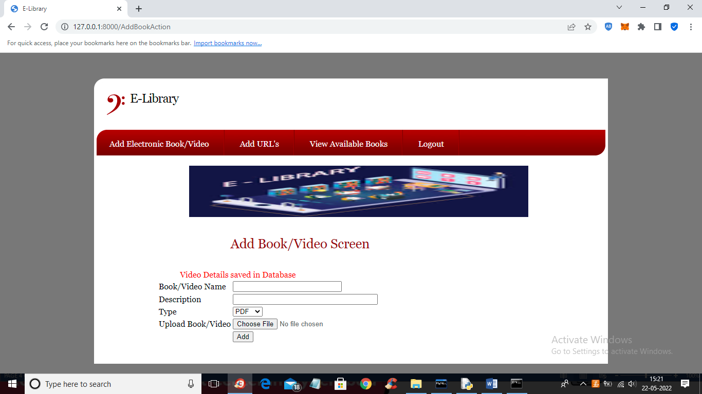

In above screen video details saved in database and now click on ‘Add URL’s’ link to add URL for tutorials

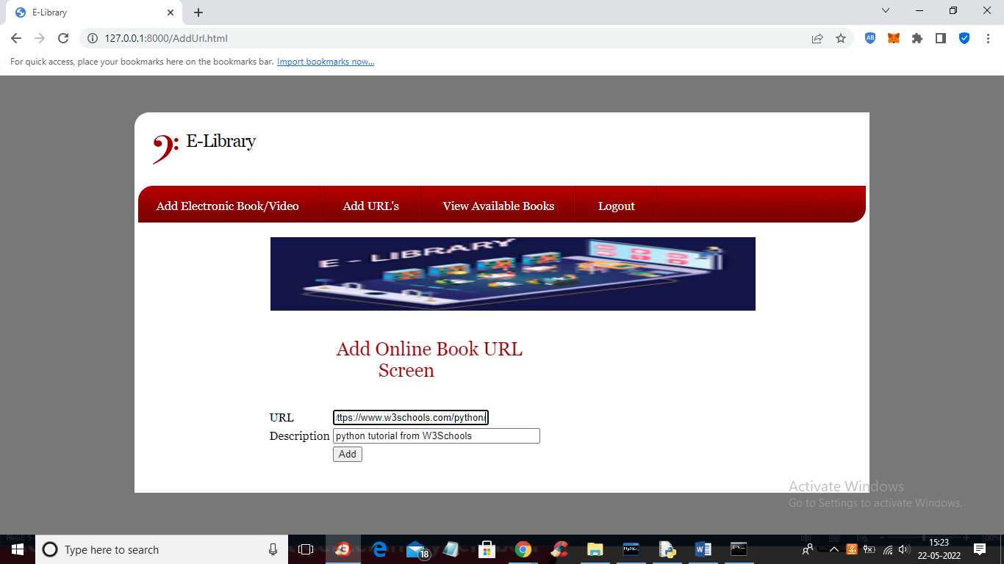

In above screen admin is adding URL tutorial and click button to get below output

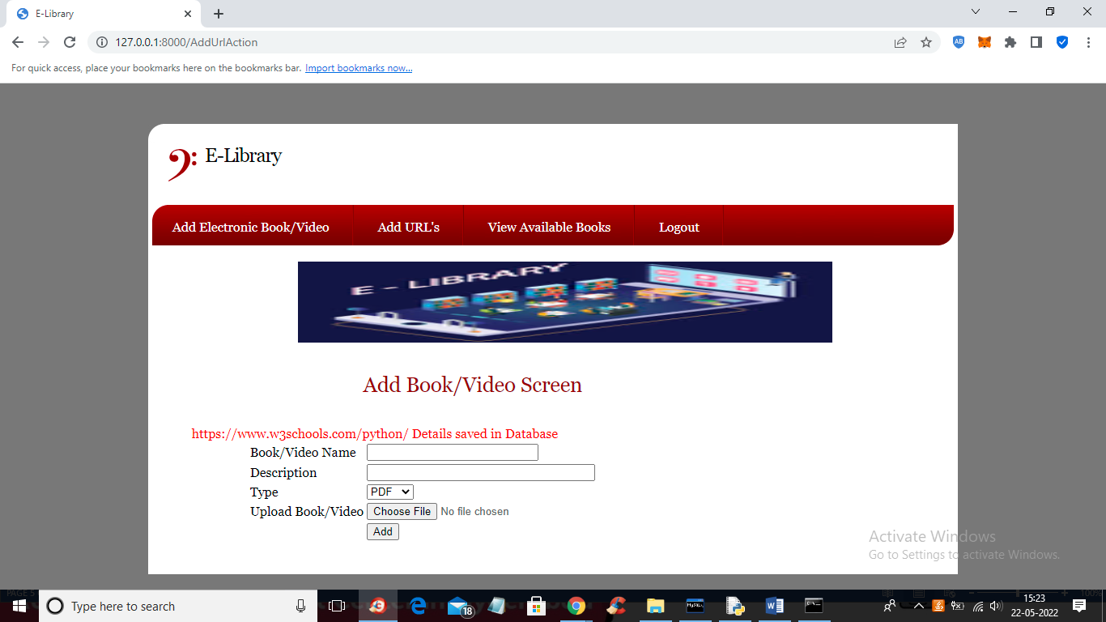

In above screen tutorial is added and now click on ‘View Available Books’ link to view below output

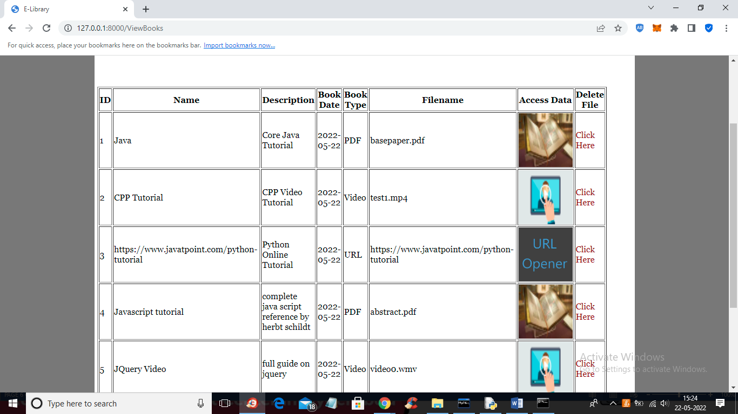

In above screen admin can view all book details and then click on desired image to view its tutorial or Click Here to delete that tutorial. So admin can add and delete tutorial

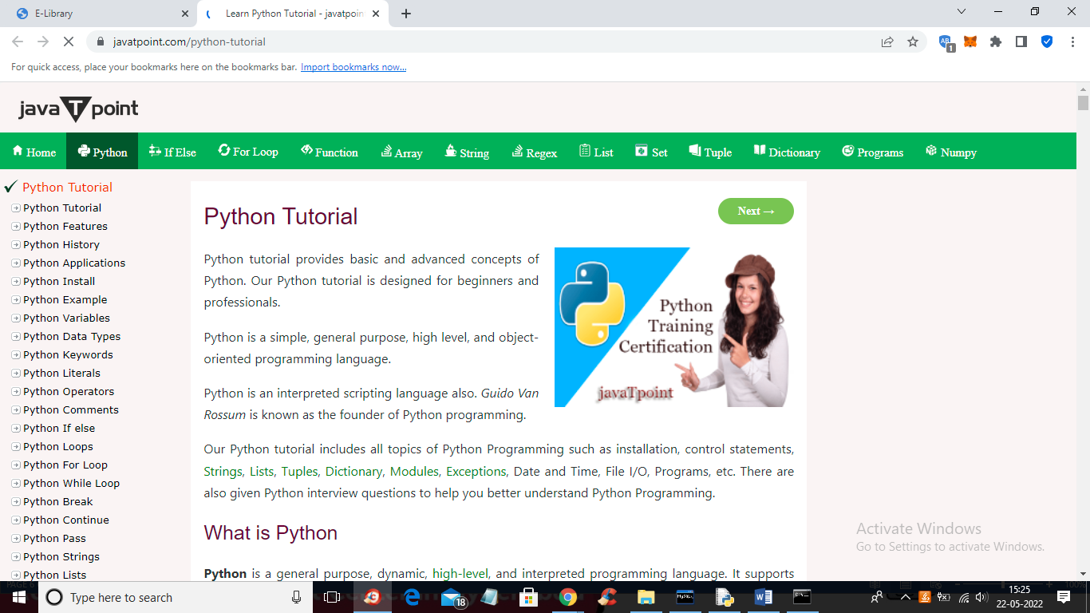

In above screen tutorial URL is open and in below screen we can see VIDEO

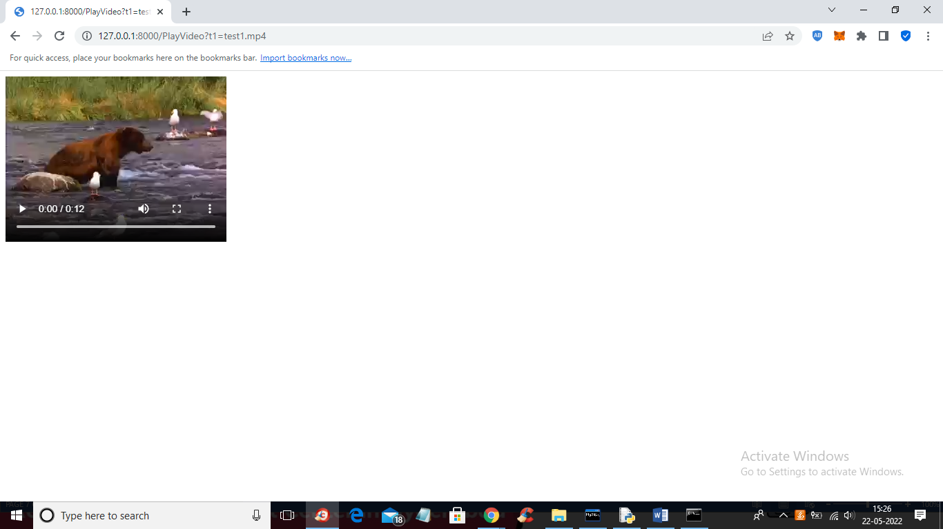

In below screen we can open PDF tutorial

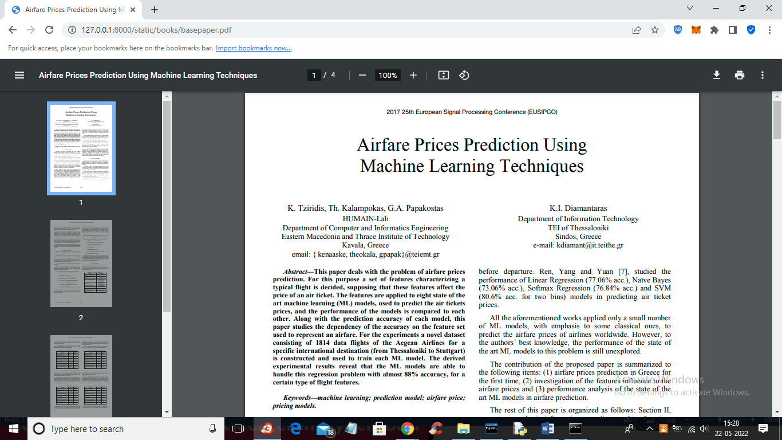

In above screen PDF tutorial is open and similarly admin can delete any tutorial and now logout and signup student

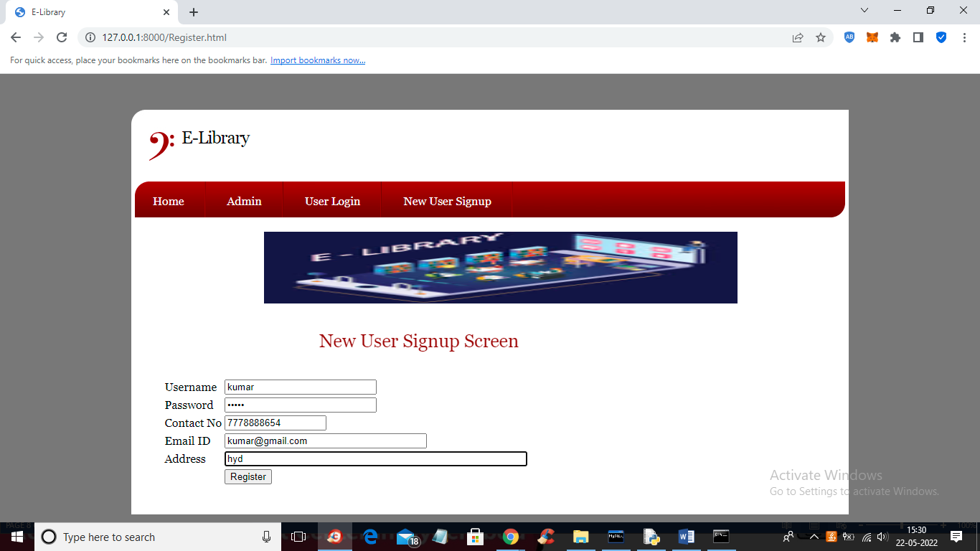

In above screen student is signing up and then click button to get below output

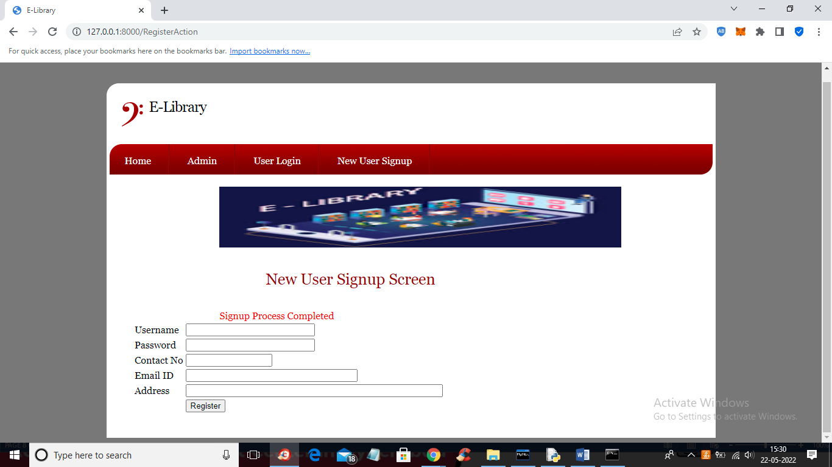

In above screen signup process completed and now click on ‘User Login’ link to get below screen

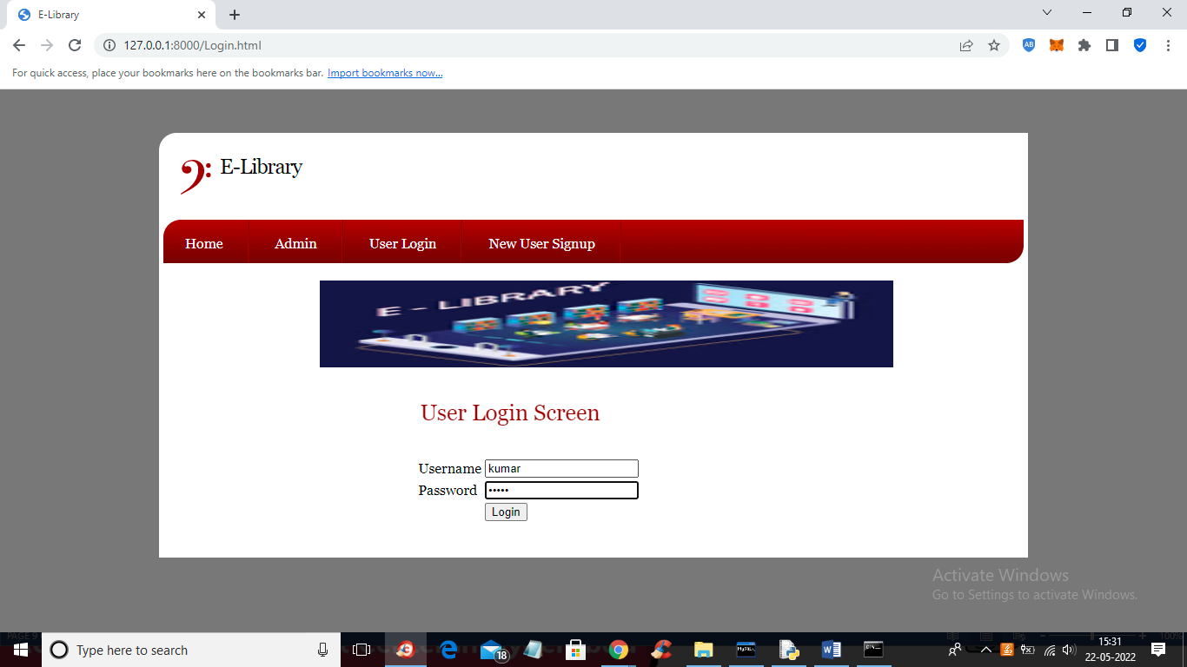

In above screen user is login and after login will get below screen

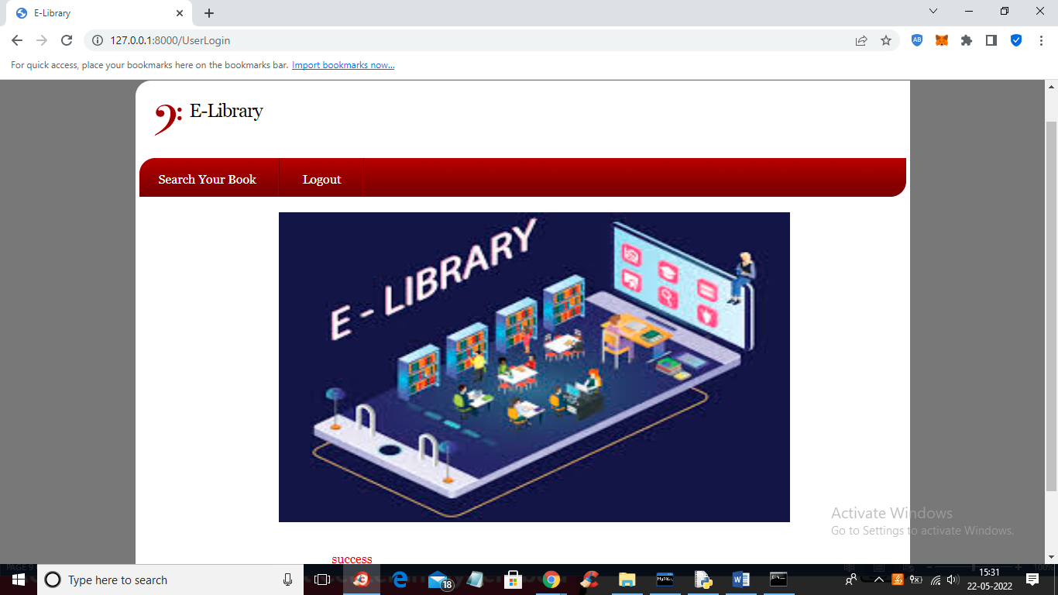

In above screen click on ‘Search Your Book’ link to get below screen

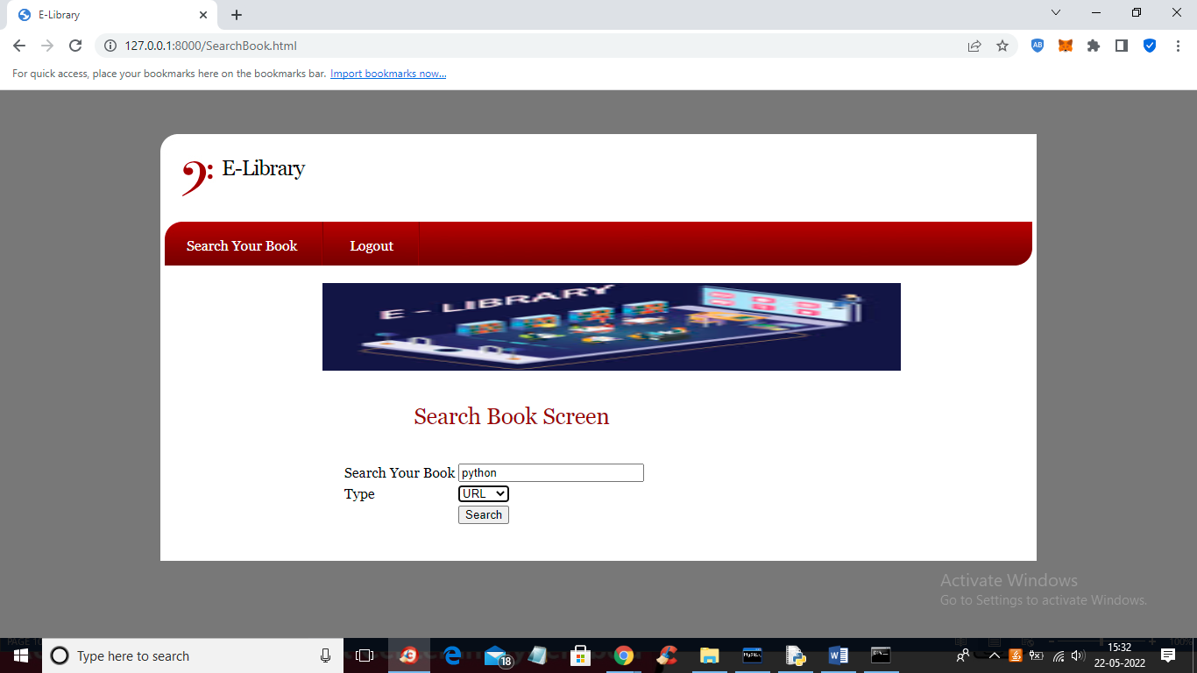

In above screen user is searching python tutorial with URL and get below output

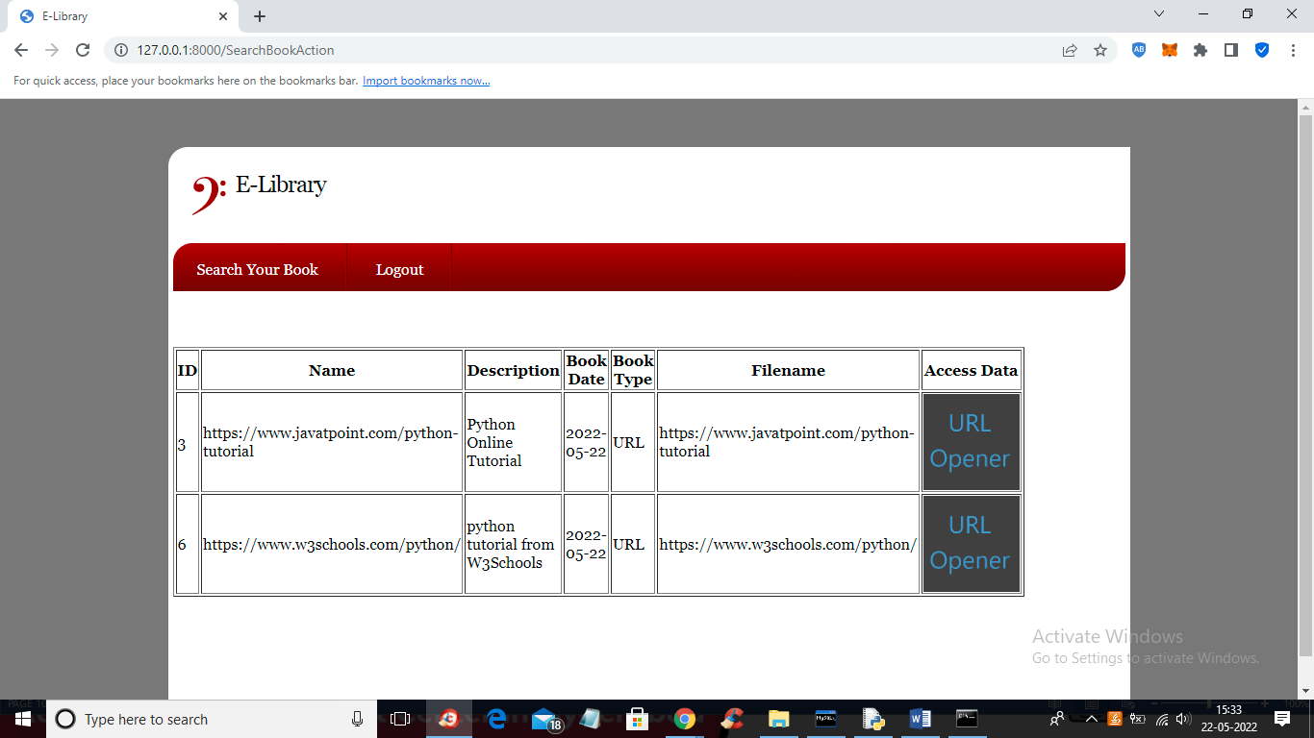

In above screen user will get all URLS for python tutorial and can click on ‘URL Opener’ link to visit that URL

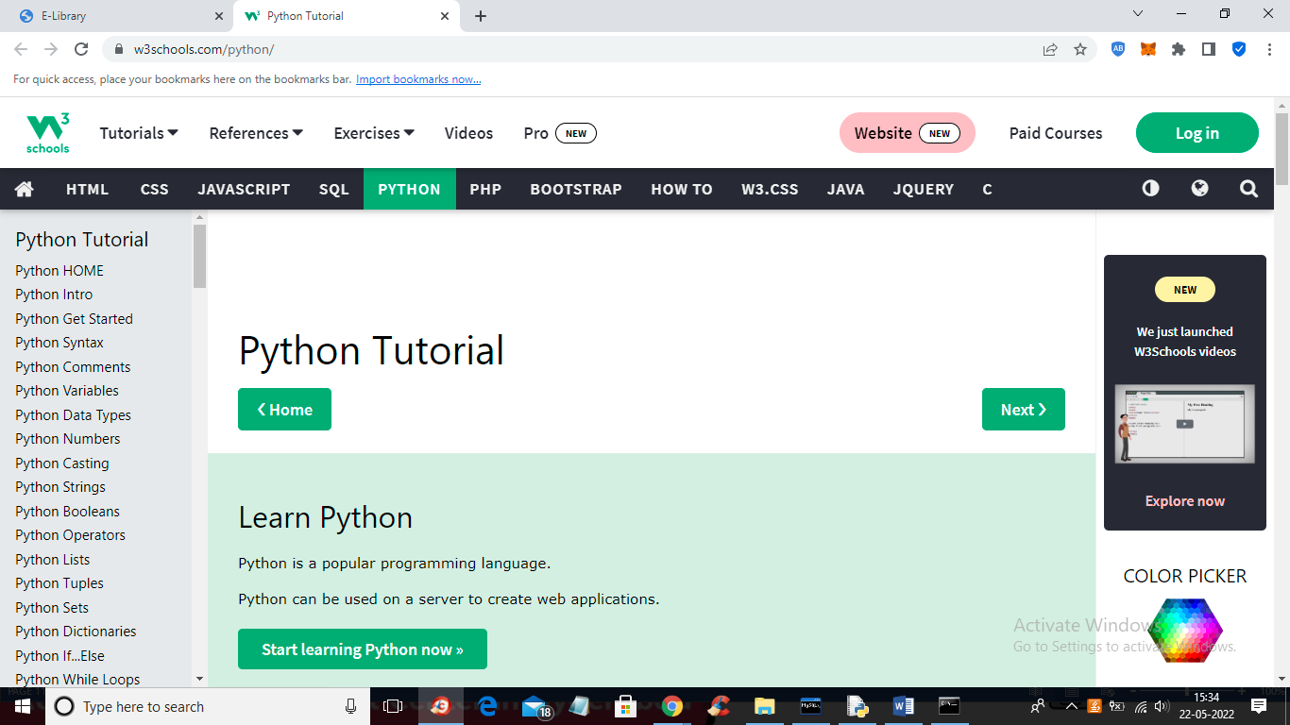

In above screen user can open and read tutorial from URL and in below screen I am searching another query

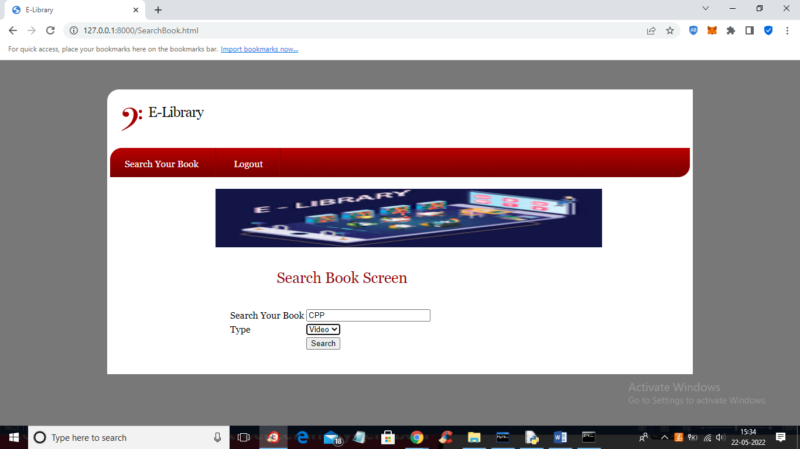

In above screen I am searching CPP video based tutorial and click button to get below output

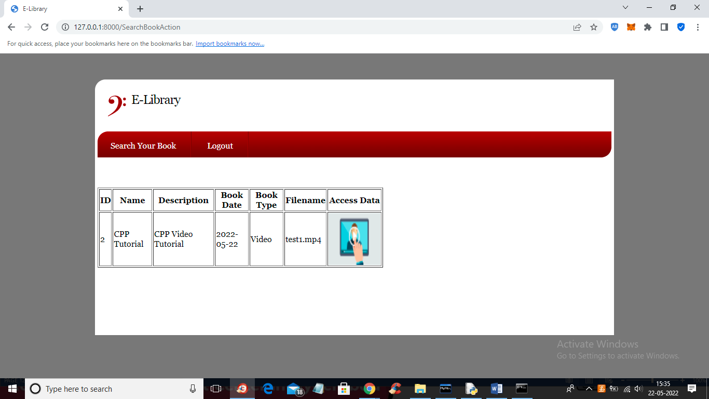

In above screen user can click on ‘PLAY ICON” to play tutorial

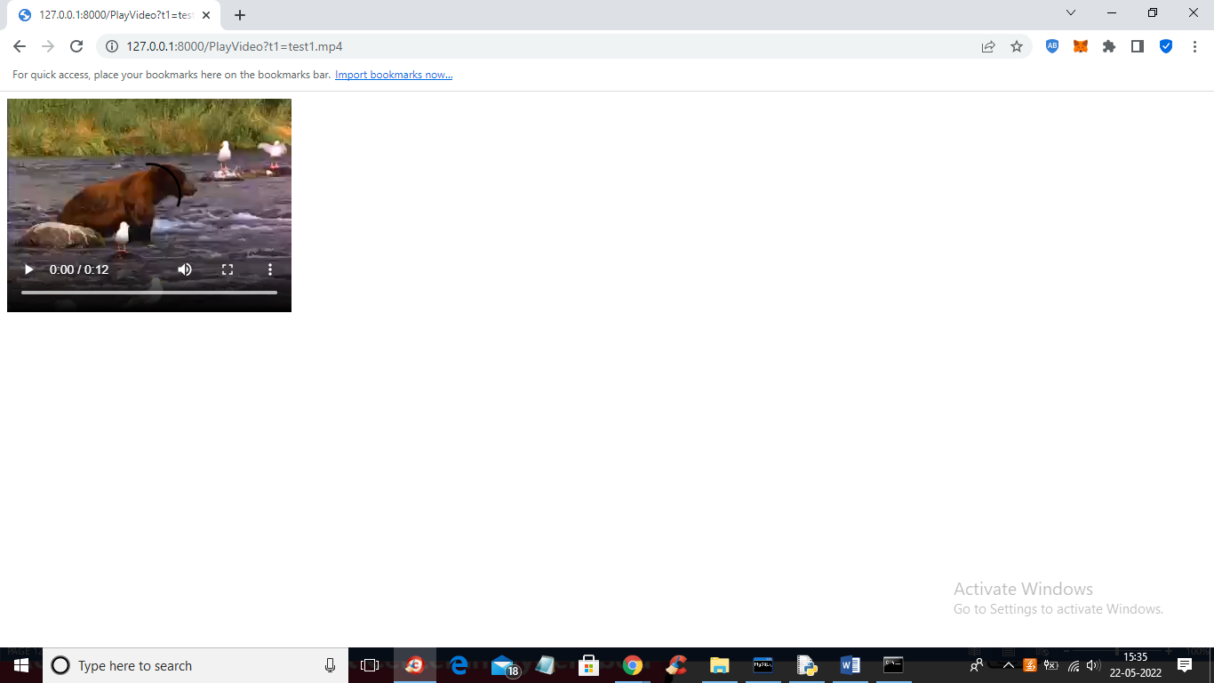

In above screen tutorial is playing and similarly you can add and search any tutorial